Mrs. Boyd 2017-2018 Syllabus:
Introduction:
Welcome parents and students to English I! I’m looking forward to the year ahead of us. To begin, my name is Hailee Boyd, and I have a devoted passion for both kids and English. I am a Flower Mound High School graduate, so this place is home for me. I obtained my Bachelor’s degree in secondary English education from Oklahoma State University in 2016. It is my driving goal to create an inclusive learning environment that fosters student engagement, growth, and achievement.

Course Description:
This course provides students the opportunity to learn the foundational skills necessary for success in subsequent high school English classes and examines the full range of language arts skills, integrating vocabulary, grammar, writing, and reading. The literature component is essentially a genre study, so students will examine with equal emphasis selections of poetry, drama, non-fiction, short story and the novel from varied cultures and regions. Students will respond to the literature by writing formal and informal compositions. In addition, students will acquire a more sophisticated vocabulary and explore the grammatical skills essential to writing.

Contact Info:
Email: hunnh@lisd.net
Work Phone: 972-219-6156
Room #: 9214

To both parents and students...please feel free to reach out anytime.

Tutorial Times:
Tuesday: 7:50-8:20am; 3:35-3:50pm
Wednesday: 7:50-8:20am; 3:35-3:50pm
Thursday: 7:50-8:20am; 3:35-3:50pm

It is the student’s responsibility to communicate with me about when they plan on attending tutoring and what specifically they need help with. If you are unable to make any of these tutorial times, please contact me and we can set up a time that works for both of us.

Materials:
BRING EVERY DAY:
- ENGL I Notebook (**Must be a 5-subject notebook with dividers**)
- Pencils, Pens, AND Highlighters
- FULLY charged Ipad
- SSR Book
- Any assignments due that day

We will use these materials every single day!

Classroom Website:
Classroom Website Link
- Access class calendar
- Access resource pages and videos
- Access presentations and documents from class

Classroom Policies:
Cell Phone Policy
Unless stated otherwise, cell phones should be silent and put away during class time. In other words, I shouldn’t see it or hear it. At times, I do allow students to listen to music using headphones during independent work. However, this is a privilege that must be earned throughout the school year. Phone disruptions will result in technology confiscation for the remainder of the class period, parent contact, and formal write-ups for persistent phone violations.

Please note that a cell phone is NOT a suitable replacement for an iPad.

iPad Policy
Students are expected to bring their iPads fully charged to school every day. We will use the iPads frequently in this class, so it is imperative that students charge their devices BEFORE coming to school. However, it is recommended that they also bring the appropriate charging devices to school as well. Again, cell phones will not be an acceptable replacement for an uncharged or broken iPad.

Late Work
You have ONE day to turn in late work for up to a 70%. After that, the assignment goes into the gradebook as a zero. Please keep up with assignments to ensure they are turned in on time.

Make up Work
Work missed due to absences will be handled according to district policy, which is explained in the student handbook. If a student is absent one day, he or she has one day to make up the missed assignments. It is the student’s responsibility to attend tutoring for make-up work and to turn in late work on the next day. Requests for make-up work must be made before or after class. There is a time limit on make-up work. Students must follow the guidelines given in the student handbook.

Re-Testing
Objective tests may be retaken for the highest possible score of 70. Quizzes cannot be taken over. Students are responsible for scheduling a re-test time with the teacher within one week of receiving the failed test paper. Re-tests will not be offered after this period.

Behavior Expectations
It is an expectation that all people (peers, teachers, administrators, guests, etc.) are treated with respect. Students will participate in frequent collaborative assignments in various groups. Mutual respect among peers will be imperative to the success of the entire class. The goal is to create an environment where all ideas, backgrounds, and cultures are not only accepted but celebrated as a means of fostering a rich and diverse learning culture.

Plagiarism/Cheating
You must research, create, and compose your own essays and projects. If you incorporate research, you must appropriately document the source with citations and bibliographical entries. Do not copy another student’s work whether it is a daily worksheet or another assignment. If you plagiarize or cheat, you will receive a zero on the assignment and possibly fail the course. Talking during a test will result in a zero. You are responsible for your actions.

Progress Reports
Printed progress reports are provided every 3 weeks to students who have an average below 75. All students and parents are encouraged to follow student progress on Skyward.

Remind
All students (and parents) are highly encouraged to sign up for remind texts alerts for my class. Every week I input text homework and test reminders that are sent to every student via cell phone or e-mail. These alerts help students make sure they are staying on track and do not forget assignments.

To join:
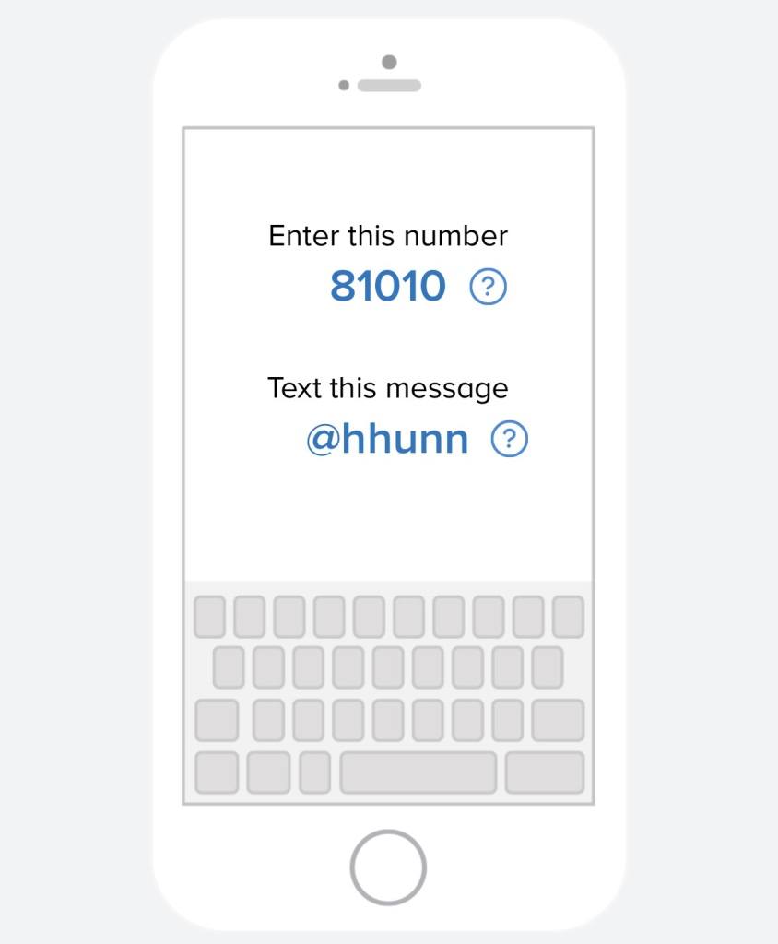

BYOT
LISD is committed to make learning opportunities available through Bring Your Own Technology. It is our goal that students and teachers will collaborate in rich, engaging learning experiences using technology. Students may bring their own technology (notebooks, iPads, and e-Readers) and utilize personal electronic communication devices in the classroom when the teacher deems them appropriate for educational purposes. FM9 is a 1:X campus and the iPad is the preferred method of technology. All inappropriate and/or non-academic use of personal technology will result in disciplinary consequences. A CELL PHONE IS NOT AN ACCEPTABLE SUBSTITUTE FOR AN IPAD.

